
K L (DEEMED TO BE) UNIVERSITY
DEPARTMENT OF COMPUTER SCIENCE AND ENGINEERING
AI-BASED FARM CREDIT AND CROP YIELD
ASSESSMENT SYSTEM
A PROJECT REPORT
Data Science Project – 1 (23IE4053R / 23IE4053A)
Submitted in partial fulfillment of the requirements for the award of the degree of
BACHELOR OF TECHNOLOGY
in Computer Science and Engineering
Submitted by
V. Maneesh Kumar Reddy – 2420030246
K. Kumar Satya Sai – 2420030202
B. Kamalesh – 2420030156

Under the guidance of
Dr. Prathusha
Professor
Department of Computer Science and Engineering
Academic Year 2026–2027 | Semester VII
K L (Deemed to be) University, KLH Bowrampet Campus, Hyderabad

K L (Deemed to be) University
Department of Computer Science and Engineering
Declaration
The Project Report entitled “AI-BASED FARM CREDIT AND CROP YIELD ASSESSMENT SYSTEM” is a record of bonafide work of 2420030246 (V. Maneesh Kumar Reddy), 2420030202 (K. Kumar Satya Sai) and 2420030156 (B. Kamalesh), submitted in partial fulfillment for the award of B.Tech in CSE to K L (Deemed to be) University. The results embodied in this report have not been copied from any other department / University / Institute.
2420030246 – V. Maneesh Kumar Reddy
2420030202 – K. Kumar Satya Sai
2420030156 – B. Kamalesh

K L (Deemed to be) University
Department of Computer Science and Engineering
CERTIFICATE
This is to certify that the project report entitled “AI-BASED FARM CREDIT AND CROP YIELD ASSESSMENT SYSTEM” is a bonafide work done and submitted by 2420030246 (V. Maneesh Kumar Reddy), 2420030202 (K. Kumar Satya Sai) and 2420030156 (B. Kamalesh) in partial fulfillment of the requirements for the award of the degree of BACHELOR OF TECHNOLOGY in the Department of CSE, K L (Deemed to be University), during the academic year 2026–2027.
Signature of the Guide
Signature of the Course Coordinator | Signature of the HOD

ACKNOWLEDGEMENT
The success of this project would not have been possible without the timely help and guidance rendered by many people. We wish to express our sincere thanks to all those who assisted us in one way or another in the completion of this work.
Our greatest appreciation goes to our Course Coordinator, [Course Coordinator name – confirm], and our guide, Dr. Prathusha, Department of CSE, for their tremendous support, encouragement and guidance throughout this project.
We express our gratitude to [HOD name – confirm; HealthScope reference lists Dr. P. Venkateshwar], Head of the Department of CSE, for providing us with adequate facilities, ways and means by which we were able to complete this project.
We thank all the members of the teaching and non-teaching staff who assisted us directly or indirectly in the successful completion of this project. Finally, we sincerely thank our parents, friends and classmates for their kind help and cooperation during our work.
2420030246 – V. Maneesh Kumar Reddy
2420030202 – K. Kumar Satya Sai
2420030156 – B. Kamalesh
ABSTRACT
Agriculture plays an important role in economic development, yet farmers often find it difficult to estimate crop yield and to make informed cultivation and financial decisions. This project presents an AI-Based Farm Credit and Crop Yield Assessment System, a web-based decision-support platform that brings agronomic and financial indicators together in one workflow. The system analyses crop type, location, season, farm area, rainfall, temperature, soil type, irrigation, fertilizer and pesticide usage, previous crop yield, farming experience, land ownership, banking and loan history, income and outstanding debt.
Three analytical modules are implemented. A rule-based, multiplicative yield prediction engine estimates crop yield and total production and compares them with state and national baselines. An interpretable credit-assessment module combines banking history (30 points), farming experience and practices (20), land ownership and size (15), agricultural viability (20) and crop-market viability (15) into a 100-point score, which feeds loan-eligibility logic with debt-burden and default-history adjustments. A soil-health and agricultural-viability model (soil health 40, crop suitability 35, seasonal fit 25) supplies the agricultural component. Results are presented in an interactive dashboard with score breakdowns, confidence indicators, benchmark comparisons and recommendations. The application is built with React and TypeScript and uses a Supabase client for persistence.
The present implementation is a deterministic prototype. It does not train or validate a statistical machine-learning model and therefore reports no accuracy figure; its credit rules are hand-designed heuristics that have not been calibrated against loan-default outcomes, its regional soil data are a static database, and its loan amounts and interest values are prototype policy rules, not bank lending terms. Its strength is interpretability: every output can be traced to identifiable inputs and explicit rules. Integration of validated agricultural datasets, real-time weather services and trained machine-learning models is identified as future work.
Keywords: agricultural analytics; farm credit assessment; credit scoring; crop yield prediction; soil analysis; decision support system; data science; precision agriculture.
INDEX
Chapter | Title | Contents | Page
1 | Introduction | Background; problem statement; motivation; scope; objectives; target users | 9
2 | Literature Survey | Crop-yield, credit-risk and loan-appraisal studies; research gap | 11
3 | System and Data Requirements | Hardware; software; functional requirements; data inventory | 13
4 | Technology Stack | React; TypeScript; services; Supabase | 15
5 | System Architecture | Layers; components; data flow; workflow | 16
6 | Data Understanding and Preparation | Input variables; soil database; preparation steps | 18
7 | Feature Engineering and Analytical Indicators | Derived indicators; factor influence | 20
8 | Analytical Methodology | Credit, viability, yield and loan-eligibility models | 21
9 | Implementation and User Interface | Pages; dashboard; screens | 24
10 | Results and Analysis | Outputs; interpretability; comparison | 27
11 | Testing and Validation | Test cases; planned tests; validation status | 29
12 | Challenges and Limitations | Challenges; limitations; ethics | 31
13 | Conclusion and Future Scope | Conclusion; status; plan; future work | 32
14 | References and Appendices | References; appendices | 34
LIST OF FIGURES
Figure | Title | Page
Figure 5.1 | System architecture of the proposed system | 16
Figure 5.2 | Data flow from inputs to dashboard outputs | 17
Figure 8.1 | Point allocation of the credit score and the agricultural viability score | 21
Figure 8.2 | Rule-based yield prediction engine | 22
Figure 8.3 | Loan-eligibility decision logic | 22
Figure 9.1 | Farmer registration page | 24
Figure 9.2 | Banking history page | 25
Figure 9.3 | Crop planning page | 25
Figure 9.4 | Soil analysis page | 25
Figure 9.5 | Credit score and loan-eligibility page | 25
Figure 9.6 | Crop-yield prediction view | 25
Figure 9.7 | Dashboard overview | 26
LIST OF TABLES
Table | Title | Page
Table 1.1 | Organisation of the report | 10
Table 2.1 | Surveyed studies and their relevance | 11
Table 3.1 | Hardware requirements | 13
Table 3.2 | Software requirements | 13
Table 3.3 | Data sources used by the system | 14
Table 4.1 | Technology stack | 15
Table 5.1 | Architecture components | 16
Table 6.1 | Input variables grouped by category | 18
Table 6.2 | Attributes stored in the regional soil database | 18
Table 7.1 | Derived indicators and how they are computed | 20
Table 8.1 | Components of the 100-point credit score | 21
Table 8.2 | Agricultural viability components | 22
Table 8.3 | Loan-eligibility adjustments | 23
Table 9.1 | Application pages and elements | 24
Table 10.1 | Implemented analytical outputs | 27
Table 10.2 | Rule-based prototype compared with typical machine-learning approaches | 27
Table 11.1 | Test cases and evidence | 29
Table 11.2 | Planned tests | 29
Table 13.1 | Implementation status | 32
Table 13.2 | Project phases | 32

CHAPTER 1 – INTRODUCTION

1.1 Background
Agriculture supports a large share of livelihoods and economic activity, but farm decisions are still frequently made on the basis of personal experience rather than data. At the same time, modern farms generate or depend on many kinds of data: financial and banking records, land and ownership details, soil characteristics, weather variables, crop histories and production practices. Combining these heterogeneous inputs can support better planning than relying on any one of them alone.
Research on crop-yield prediction shows frequent use of environmental, soil and historical-yield variables, with Random Forest, artificial neural networks, support vector machines and gradient-boosting methods among the approaches most often investigated [1], [4]. Agricultural finance raises a related question: a farmer’s repayment capacity cannot be judged from a conventional credit attribute alone, because income and repayment potential depend on land holding, crop selection, irrigation, soil productivity, previous loans and expected production [3], [5].
This project, the AI-Based Farm Credit and Crop Yield Assessment System, addresses both questions in one browser-based analytical platform. It collects farmer, banking, land, crop and soil information, derives interpretable intermediate scores, estimates yield and production, and produces a final credit assessment and loan-eligibility indication that are presented on a single dashboard.

1.2 Problem Statement
Farmers often lack reliable tools to estimate crop yield and assess overall farm health before making important cultivation and financial decisions. Yield estimates depend heavily on manual experience or guesswork, which leads to inaccurate financial planning and poor credit-related decisions. Existing platforms rarely combine agronomic factors (soil, rainfall, irrigation, fertilizer and pesticide usage) with financial and credit evaluation in one place, and many are too complex for users with limited digital literacy.
The problem addressed by this project is to design and implement a simple, accessible, data-driven web system that (a) collects farm, financial and environmental inputs, (b) estimates expected yield and production using transparent logic, (c) assesses farm-credit readiness using agronomic and financial indicators together, and (d) explains the outcome through an interactive dashboard with recommendations.

1.3 Motivation
- Informed cultivation decisions: a yield estimate with benchmark comparison helps a farmer judge whether a crop plan is realistic before committing resources.
- Joint view of farm and finance: repayment capacity is linked to expected production, so yield, soil and credit indicators should be evaluated together rather than in separate tools.
- Explainability: a visible, rule-based breakdown shows which factors drive a low or high result, which black-box models rarely do.
- Suitability where data are scarce: rule-based logic does not need a large labelled training dataset, which is often unavailable for regional agricultural lending.
- Foundation for future work: a modular design allows real-time weather feeds, validated datasets and trained machine-learning models to be added later.

1.4 Scope
The system covers farmer registration and profile management, banking and loan-record capture, crop planning and farming-practice collection, soil analysis and agricultural-viability scoring, credit scoring and loan-eligibility assessment, crop-yield prediction with benchmark comparison, and a dashboard with saved assessment data.
The implementation is a deterministic decision-support prototype. Its credit score and yield estimate are produced by explicit rules and not by a trained model; it does not predict the probability of loan default, is not a replacement for a bank’s validated credit-risk model, and does not claim statistical machine-learning accuracy. External validation, calibration against historical lending outcomes and production deployment are outside the scope of the work completed so far and are recorded as future work.

1.5 Objectives
- Design a web-based system that analyses crop type, location, season, farm area, rainfall, temperature, soil type, irrigation, fertilizer, pesticide usage and previous crop yield.
- Estimate expected crop yield and total production using transparent rule-based prediction logic.
- Assess farmer credit readiness using banking, loan, farming, land, agricultural and crop-market indicators.
- Build an interactive dashboard displaying predicted yield, total expected production, confidence indicators and state-level and national-level comparisons.
- Visualise the influence of farming factors and provide actionable recommendations for irrigation, soil quality, fertilizer usage and crop management.
- Store assessment information and present it through the dashboard for user review.
- Provide a lightweight foundation for future integration with real-time weather data, validated agricultural datasets and trained machine-learning models.

1.6 Importance and Target Users
The intended users are farmers, agricultural extension workers, rural-finance officers and other agricultural stakeholders who need an accessible, explainable view of farm conditions and credit readiness. The system is also suitable as an academic demonstration of an end-to-end data-science workflow and as a starting template for larger agricultural analytics platforms. It is a screening and decision-support aid; it does not issue loans and does not replace the judgement of a bank or agricultural expert.

1.7 Organisation of the Report
Table 1.1 – Organisation of the report
Chapter | Focus
1 | Introduction – background, problem statement, motivation, scope and objectives
2 | Literature Survey – related work on crop-yield prediction and farmer credit risk; research gap
3 | System and Data Requirements – hardware, software, functional requirements and data inventory
4 | Technology Stack – frameworks and services used and their roles
5 | System Architecture – layers, components and data flow
6 | Data Understanding and Preparation – input variables, soil database and preparation steps
7 | Feature Engineering and Analytical Indicators – derived indicators and factor influence
8 | Analytical Methodology – credit, viability, yield and loan-eligibility models
9 | Implementation and User Interface – modules, pages and assessment flow
10 | Results and Analysis – outputs, interpretability and comparison with ML approaches
11 | Testing and Validation – tests performed and planned
12 | Challenges and Limitations
13 | Conclusion and Future Scope
14 | References and Appendices

CHAPTER 2 – LITERATURE SURVEY

2.1 Overview
Crop-yield prediction, agricultural decision support and farmer credit risk have each been studied extensively, but usually as separate problems. The studies surveyed here fall into three groups: machine-learning crop-yield and crop-prediction work, farmer credit-risk and agricultural loan-appraisal work, and recent explainable and multivariate agricultural-prediction work. Together they motivated three design decisions in this project: considering several agronomic variables together, treating credit and yield as linked questions, and favouring outputs whose drivers can be explained.

2.2 Crop-Yield and Crop-Prediction Studies
Jhajharia et al. [1] compared Random Forest, Support Vector Machine, Gradient Descent, LSTM and Lasso Regression for crop-yield estimation on historical crop and weather data and reported Random Forest as the strongest performer on their Rajasthan dataset. Elbasi et al. [2] investigated machine-learning approaches to crop prediction and emphasised the use of agricultural records and sensor information to make farm decisions more data-driven. A Wiley-IEEE Press chapter [4] predicted crop yield and soil moisture with several machine-learning algorithms using environmental variables such as rainfall, temperature, humidity and soil moisture.

2.3 Farmer Credit Risk and Loan Appraisal
Chai et al. [3] developed a farmer credit-risk framework using data from 8,624 farmers and reported that their machine-learning framework identified loan-default risk better than traditional econometric approaches. The study demonstrates the value of data-driven farmer credit assessment but concentrates on financial risk and does not bring agronomic production indicators into the model. Pushpalatha et al. [5] proposed a farmer-friendly, AI-powered smart agriculture loan-appraisal system that takes land yield capacity into account, which directly motivates linking agricultural indicators with financing decisions.

2.4 Recent Multivariate and Explainable Approaches
Kumar et al. [6] predicted agricultural production from multivariate environmental and agronomic variables – including N, P, K, rainfall, temperature, humidity, soil quality and soil pH – using feature-aware machine-learning models and stressed explainability. Snehalatha and Patil [7] presented AgriYieldAI, an AI-driven decision-support system for crop-yield prediction built around a model named YieldFusionNet. These works show the field moving towards multimodal and explainable agricultural decision support.

2.5 Summary of Surveyed Studies
Table 2.1 – Surveyed studies and their relevance
Ref. | Authors (year) | Focus | Relevance to this project
[1] | Jhajharia et al. (2023) | Crop-yield prediction with RF, SVM, LSTM, Lasso | Supports multi-factor yield prediction; yield only, no credit view
[2] | Elbasi et al. (2023) | Crop prediction with ML and sensor data | Supports data-driven farm decisions
[3] | Chai et al. (2025) | ML credit-risk framework for farmers (8,624 farmers) | Shows value of data-driven farmer credit assessment; no agronomic indicators
[4] | Wiley-IEEE Press chapter (2024) | Yield and soil-moisture prediction | Supports soil and environmental features
[5] | Pushpalatha et al. (2026) | AI-powered agricultural loan appraisal using land yield capacity | Directly motivates integrated farm-credit appraisal
[6] | Kumar et al. (2026) | Multivariate agricultural production prediction (N, P, K, rainfall, pH, etc.) | Supports multivariate analysis and explainability
[7] | Snehalatha and Patil (2026) | AgriYieldAI decision-support system (YieldFusionNet) | Indicates direction toward explainable, multimodal decision support

2.6 Research Gap and Contribution of This Project
The reviewed literature indicates a gap between specialised yield-prediction systems and farmer credit-risk systems. Yield studies [1], [2], [4], [6], [7] largely ignore a farmer’s financial position, while credit studies [3] largely ignore agronomic production indicators; only a few works [5] link the two. The specific gaps identified are:
- Most yield-prediction tools consider only crop-specific inputs and ignore credit readiness.
- Many platforms are technically complex and hard for users with limited digital literacy.
- Predictions are rarely explained: few tools show which factor drives a low or high estimate.
- Few lightweight, rule-based alternatives exist for regions where large historical datasets for model training are unavailable.
- Agricultural assessment is seldom connected directly to farm credit and financial decision support.
This project addresses the system-level gap by combining crop-yield estimation and farm-credit assessment in one lightweight, explainable platform. Unlike the cited machine-learning studies, the prototype intentionally uses rule-based logic so that it can run without a large labelled training dataset and can expose the factors behind each output. Its contribution is therefore an integrated and explainable data-science workflow, not a new learning algorithm.

CHAPTER 3 – SYSTEM AND DATA REQUIREMENTS

3.1 Hardware Requirements
The system is a browser-based web application whose analytical logic is lightweight and deterministic, so no GPU or specialised hardware is required. The following configuration is sufficient for development and use.
Table 3.1 – Hardware requirements
Resource | Minimum | Recommended
Processor | Dual-core 64-bit CPU | Quad-core 64-bit CPU
Memory (RAM) | 4 GB | 8 GB or more
Storage | 1 GB free (project dependencies) | 2 GB free
Display | 1366 × 768 | 1920 × 1080 for the dashboard
Network | Required for the database and external environmental-data services | Stable broadband connection

[Hardware figures are typical values for a React web application – confirm against the team’s development machines if required.]

3.2 Software Requirements
Table 3.2 – Software requirements
Software | Purpose
React and TypeScript | Implementation of the user interface and client-side analytical logic
Supabase client | Persistence of saved assessment data
Node.js and a package manager (npm) | Build tooling and dependency management – [confirm versions and build tool from package.json]
Web browser | Running the application (any current desktop or mobile browser)
Operating system | Windows, macOS or Linux – all support the web toolchain
Code editor / Git | Development and version control – [confirm editor and repository host]

3.3 Functional Requirements
- The system shall allow a farmer to register and manage a profile.
- The system shall capture banking history, income, outstanding debt and previous loan records.
- The system shall collect crop plans, season, farm area, irrigation, fertilizer and pesticide practices, previous yield and land information.
- The system shall retrieve or accept soil and environmental information (pH, organic carbon, nutrients, drainage, erosion, rainfall and temperature) for the selected location.
- The system shall compute a soil-health score, an agricultural-viability score and a 100-point credit score with its five components.
- The system shall determine loan eligibility and recommended loan parameters after debt-burden and default-history adjustments.
- The system shall estimate crop yield and total production and compare them with state and national baselines, with a confidence indicator and grade.
- The system shall present results, charts and recommendations on a dashboard and save assessment data for later review.

3.4 Non-Functional Requirements
- Usability: a first-time user should reach a result through a guided, step-by-step workflow without technical knowledge.
- Explainability: every score must be decomposed into visible components and traceable to inputs and rules.
- Maintainability: separate pages, reusable UI components and service modules keep the code modular and extensible.
- Responsiveness: deterministic calculations execute instantly in the browser, which suits an interactive dashboard.
- Honest presentation: outputs are framed as decision support and the limits of the heuristics are stated.

3.5 Data Inventory
Unlike a supervised machine-learning project, this prototype does not rely on a single labelled training dataset. Its data sources are listed below.
Table 3.3 – Data sources used by the system
Data source | Content | Nature
User-entered farmer data | Profile, banking and loan history, income, debt, farming experience, land ownership and size | Collected through the application forms
User-entered farm data | Crop, season, farm area, irrigation, fertilizer, pesticide usage, previous yield | Collected through the crop-planning forms
Regional soil database | Soil type, texture, pH, organic carbon, N, P, K, sulphur, zinc, iron, drainage, erosion and suitable crops for multiple Indian states | Static / mock regional entries in the implementation
Crop baselines and modifiers | Base yield per supported crop; state, soil, irrigation, rainfall, temperature, fertilizer and pest modifiers; state and national baselines | Predefined parameters in the prediction engine
External environmental service | Weather / environmental values shown in the soil-analysis interface | Integrated service; provider to be confirmed
Saved assessments | Stored assessment results for the dashboard | Supabase-backed storage

[Confirm from source code: the number of crops supported, the number of states in the soil database, and the external weather / soil service provider.]

CHAPTER 4 – TECHNOLOGY STACK
The project is built as a client-side web application. The table below lists each layer of the stack and its role.
Table 4.1 – Technology stack
Layer | Technology | Role in the system
Programming language | TypeScript | Type-safe implementation of the application and analytical logic
UI framework | React | Component-based user interface and page structure
UI components | Reusable forms, cards, charts, dialogs, progress indicators, tables and navigation | Consistent interface and data visualisation – [confirm UI and chart libraries]
Service modules | Soil, district, authentication, saved-data and environmental-data services | Separate data access and domain logic from pages
Persistence | Supabase client | Storing and retrieving saved assessments
Analytics | Deterministic rule engines | Credit scoring, viability scoring, loan eligibility and yield prediction

4.1 React and TypeScript
React composes the interface from reusable components, which suits a multi-step assessment where each page (registration, banking history, crop planning, soil analysis, credit score and dashboard) shares common form, card and chart elements. TypeScript adds static typing, which reduces errors when the same farm and financial attributes are passed between pages, services and scoring functions.

4.2 Service Modules
Service modules isolate everything that is not presentation: the regional soil database, district information, authentication, saved-data handling and the integration with external environmental data. This keeps pages thin and makes it possible to replace the static soil data with an authoritative source later without changing the interface.

4.3 Supabase
A Supabase client is included for persistence so that assessment results can be stored and shown again on the dashboard. The application also contains authentication and saved-data services. Database table definitions and access rules are not described in the source material and are listed in Appendix D as items to be confirmed.

4.4 Rule-Based Analytics Instead of a Machine-Learning Library
No machine-learning framework is used in the present implementation. Credit scoring, agricultural viability, loan eligibility and yield prediction are written as explicit, weighted and multiplicative rules. This is a deliberate design choice (Section 8.6): it keeps computation lightweight, removes the need for a training dataset and makes every output explainable.

CHAPTER 5 – SYSTEM ARCHITECTURE

5.1 Overall Architecture
The architecture follows a modular client-side application structure. The user interface is implemented with React and TypeScript; individual pages handle registration, banking history, crop planning, soil analysis, credit assessment and the dashboard. Service modules handle soil information, database interaction, saved data, district information and external environmental data. The analytics engines compute the viability score, the credit score, loan eligibility and the yield estimate, and a Supabase client persists the results.
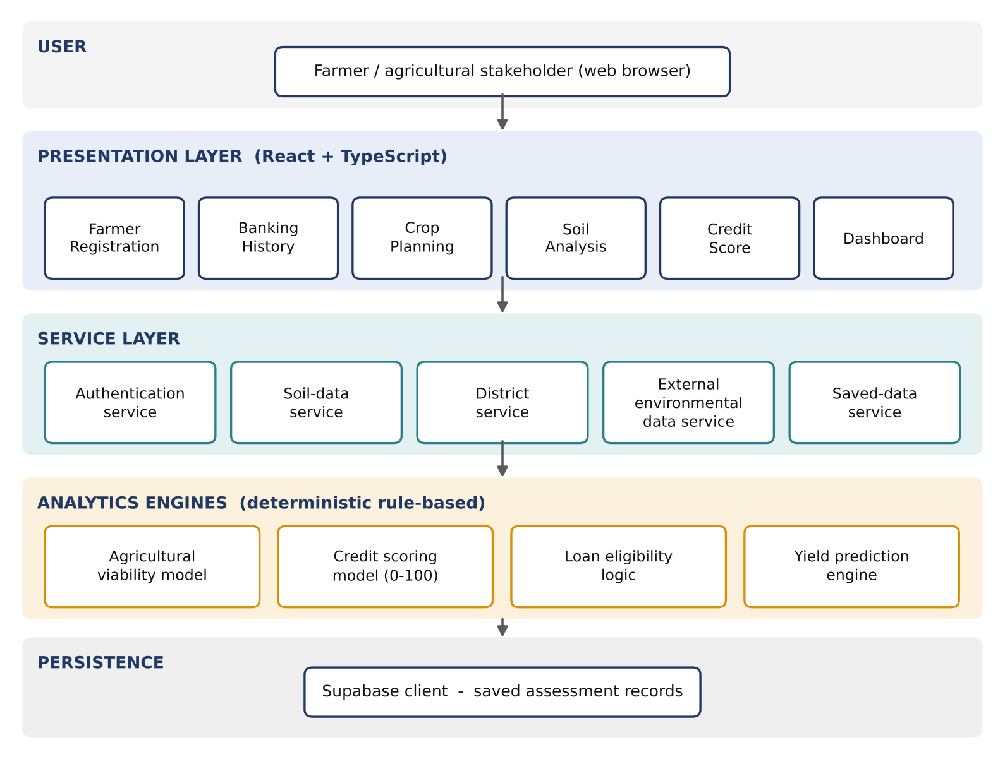
Figure 5.1 – System architecture of the proposed system
The user works through the presentation layer, which calls services for soil, district, environmental and saved data. The analytics engines are deterministic and run on the entered and retrieved values. The diagram was drawn from the project description and is not a screenshot.

5.2 Component Responsibilities
Table 5.1 – Architecture components
Component | Responsibility | Input | Output
Farmer Registration and Profile | Creates the account and stores personal and farm details | Farmer details | Farmer profile
Banking History and Loan Records | Captures account, income, debt and loan history | Banking and loan data | Repayment and debt indicators
Crop Planning | Collects crop, season, area and practice details | Crop plans, practices | Structured crop plan
Soil Analysis | Combines regional soil data and environmental values | Location, soil, crop, season | Soil-health and viability scores
Credit Score and Eligibility | Computes the 100-point score and eligibility | All indicators | Score, eligibility, loan parameters
Yield Prediction | Estimates yield and production and compares benchmarks | Crop, state, soil, climate, practices | Yield, production, grade, recommendations
Dashboard and Saved Data | Displays results and stores assessments | Assessment outputs | Charts, history, recommendations

5.3 Data Flow
The conceptual data flow is: user input produces the farmer profile and farm characteristics; banking history and loan records produce repayment and debt indicators; crop planning produces crop, season, area and management indicators; location and soil data produce pH, organic-carbon, nutrient, drainage and erosion indicators; these combine into soil-health and agricultural-viability scores; all indicators are combined into the 100-point credit score; the score together with debt burden and default history yields eligibility and loan-parameter recommendations; and crop and environmental inputs produce a yield estimate, benchmark comparison and recommendations. All outputs flow to the dashboard and to saved records.
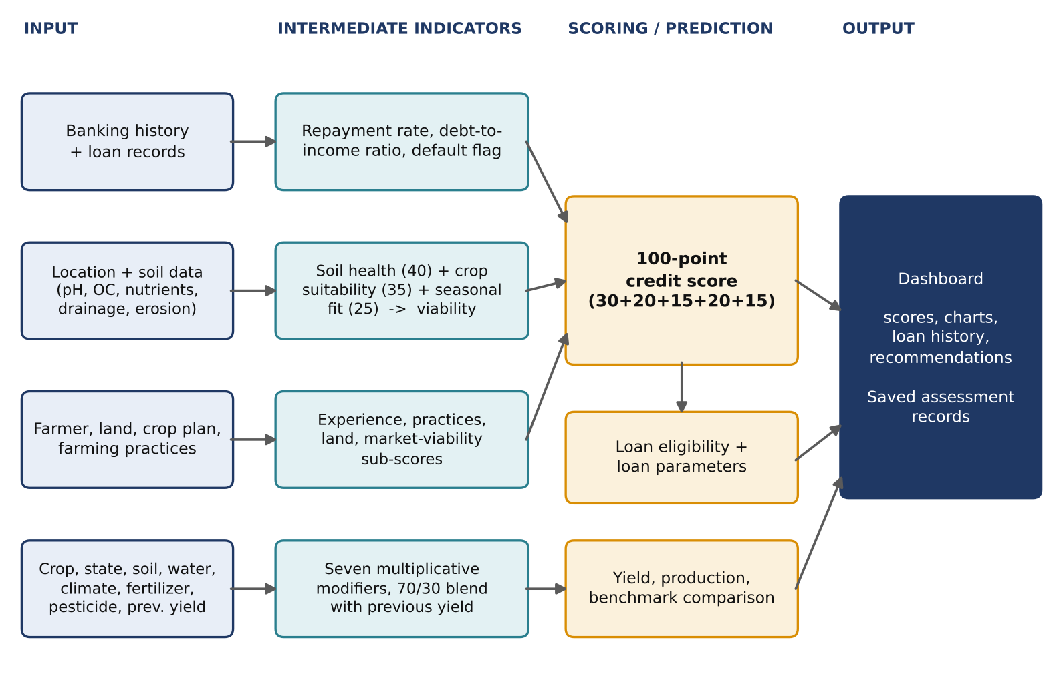
Figure 5.2 – Data flow from inputs to dashboard outputs

5.4 Design Principles
- Modularity: pages, services and analytics engines are separate, so each can change independently.
- Explainability by design: every score is built from named components with stated maximum points.
- Staged data capture: a sequential workflow collects data in the order a farmer can supply it and feeds each stage’s indicators into the next.
- Replaceable data sources: static soil and baseline data sit behind services so authoritative datasets or live weather feeds can replace them.
- Honest presentation: the interface presents decision-support outputs, not unexplained credit decisions.

5.5 Assessment Workflow
- The farmer creates an account and enters personal and farm information.
- Banking history and previous loan records are captured.
- Crop plans, farming practices and land information are entered.
- Soil analysis retrieves regional soil data and, where available, environmental values.
- Soil-health and agricultural-viability scores are computed.
- The credit score and loan eligibility are computed, with debt and default adjustments.
- The yield engine estimates yield and production and compares them with baselines.
- The dashboard consolidates scores, loan history, crop information, soil health and recommendations, and assessment data are saved.

CHAPTER 6 – DATA UNDERSTANDING AND PREPARATION

6.1 Overview of the Data
The system works with structured, mostly numeric and categorical inputs. These come from the farmer through the forms, from a regional soil database, from predefined crop baselines and modifiers, and from an external environmental service. There is no labelled historical loan or yield dataset in the present implementation; consequently there is no training–test split and no model-fitting step (see Section 6.5).

6.2 Input Variables
Table 6.1 – Input variables grouped by category
Category | Variables
Farmer and banking | Farming experience, banking history (account age, previous loans, average repayment rate), loan history, monthly income, outstanding debt, default history
Land | Land ownership status, land (farm) area
Crop plan | Crop type, season, number of crop plans, expected yield, previous crop yield
Location and soil | State / district, soil type, pH, organic carbon, drainage quality, erosion level
Environment | Rainfall, temperature
Practices | Irrigation, fertilizer usage, pesticide usage

6.3 Regional Soil Database
The soil-data service holds regional entries for multiple Indian states. Each entry stores the attributes in Table 6.2, which feed the soil-health score and the crop-suitability check.
Table 6.2 – Attributes stored in the regional soil database
Attribute | Description / use
Soil type and texture | Compared with the planned crop and season for crop suitability
pH | Soil-health component
Organic carbon | Soil-health component
Nitrogen, phosphorus, potassium | Primary nutrient levels shown in soil analysis
Sulphur, zinc, iron | Secondary and micronutrient levels shown in soil analysis
Drainage quality and erosion level | Soil-health components
Suitable crops | Used to assess crop suitability for the selected location

6.4 Data Preparation Steps
- Collecting inputs through staged forms so each farm and financial attribute is entered once and reused by later modules.
- Deriving the annual income as monthly income × 12 and the debt-to-income ratio as outstanding debt ÷ annualised income.
- Mapping the location to regional soil attributes and, where available, merging external environmental values.
- Converting raw inputs into component scores with fixed maximum points and normalising the agricultural score to a 100-point scale before converting it to 20 points in the credit model.
- Applying state, soil, irrigation, rainfall, temperature, fertilizer and pest modifiers to the crop baseline for the yield estimate.
[Confirm from source code: form validation rules (ranges, required fields), handling of missing inputs, and units for each variable.]

6.5 Data Not Used
The prototype does not train on a labelled dataset, so the usual machine-learning preparation steps – missing-value imputation fitted on training data, feature scaling, class balancing and a stratified train–test split – do not apply. This is a limitation, recorded in Chapter 12, and the main reason why no accuracy figure is reported.

CHAPTER 7 – FEATURE ENGINEERING AND ANALYTICAL INDICATORS

7.1 Purpose of This Chapter
In a supervised-learning project this stage would contain exploratory data analysis (distributions, correlations, feature importance). Because the present system is rule-based and has no analysed dataset, the corresponding work here is the design of derived indicators – the intermediate quantities that turn raw inputs into interpretable scores – and the visualisation of factor influence on the dashboard.

7.2 Derived Indicators
Table 7.1 – Derived indicators and how they are computed
Indicator | Derived from | Purpose
Annualised income | Monthly income × 12 | Denominator of debt-to-income ratio
Debt-to-income ratio | Outstanding debt ÷ annualised income | Debt-burden penalty at > 40 %, > 60 % and > 80 %
Banking score (max 30) | Account age, previous loans, repayment rate, income, debt, default history | Financial component of the credit score
Farming score (max 20) | Years of experience; irrigation, fertilizer, pesticide use; number of crop plans | Practice component of the credit score
Land score (max 15) | Land area and ownership status | Collateral and stability proxy
Soil-health score (max 40) | pH, organic carbon, drainage quality, erosion level | Largest part of agricultural viability
Crop suitability (max 35) | Planned crop vs season and soil type | Agronomic fit of the crop plan
Seasonal fit (max 25) | Crop vs season | Timing fit of the crop plan
Agricultural score (max 20 in credit) | Viability normalised to 100, scaled to 20 | Agricultural component of the credit score
Market-viability score (max 15) | Crop-plan diversification; availability of expected-yield information | Market component of the credit score
Factor scores and confidence | Six factor scores averaged | Internal reliability indicator for the yield estimate
Benchmark gap | Predicted yield vs state / national baseline | Context for the predicted yield

7.3 Factor Influence
The dashboard shows how individual farming factors influence the yield estimate through the factor scores and the monthly growth visualisation. This answers a common weakness identified in the literature survey: few tools show which factor is driving a low or high estimate. The visual output allows a user to see, for example, whether irrigation or fertilizer practice is the limiting factor, and the recommendation engine converts that finding into advice on irrigation, soil quality, fertilizer usage and crop management.

7.4 Planned Exploratory Analysis
When validated agricultural and loan-outcome datasets are integrated (Chapter 13), this chapter should be extended with class-balance checks, feature distributions, correlation analysis and model-based feature-importance, so the hand-set weights can be compared with empirically learned ones.

CHAPTER 8 – ANALYTICAL METHODOLOGY

8.1 Overview
Four deterministic models make up the analytical core: the credit scoring model, the agricultural viability model, the yield prediction engine and the loan-eligibility logic. Figure 8.1 shows the point allocation of the first two.
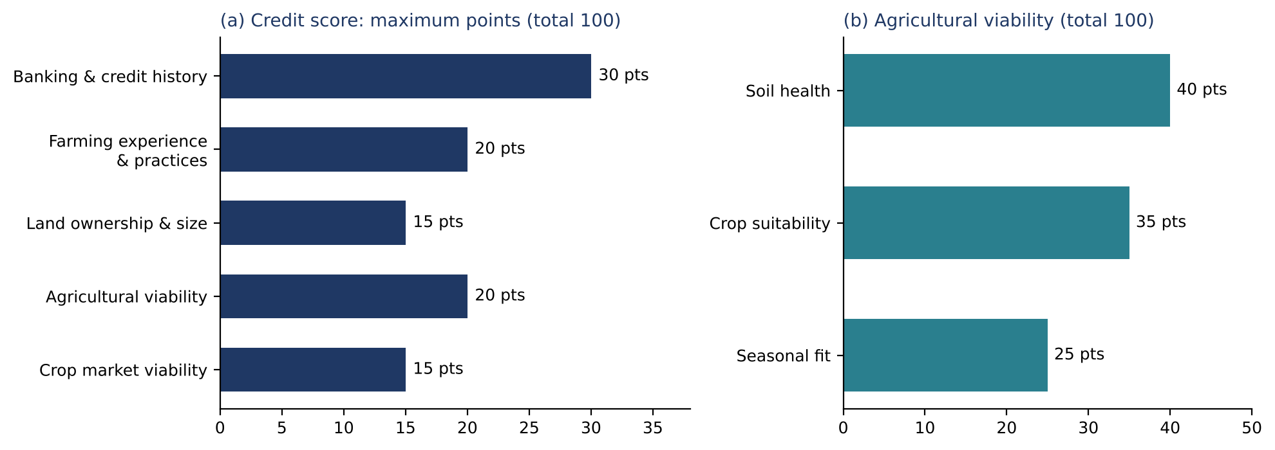
Figure 8.1 – Point allocation of the credit score and the agricultural viability score

8.2 Credit Scoring Model
The credit model is a deterministic weighted score rather than a trained classifier. The maximum score is 100 and is divided into five components:
Table 8.1 – Components of the 100-point credit score
Component | Max points | Main inputs
Banking and credit history | 30 | Account age, previous loans, average repayment rate, monthly income, outstanding debt, default history
Farming experience and practices | 20 | Years of experience; use of irrigation, fertilizer and pesticides; number of crop plans
Land ownership and size | 15 | Land area and ownership status
Agricultural viability | 20 | Soil health, crop suitability, seasonal fit (normalised and scaled)
Crop market viability | 15 | Crop-plan diversification; availability of expected-yield information
Total | 100

Overall Credit Score = Banking Score + Farming Score + Land Score + Agricultural Score + Market Score.
The debt-to-income ratio is outstanding debt divided by annualised monthly income. Debt penalties are applied when the ratio exceeds 40 %, 60 % or 80 %.

8.3 Agricultural Viability Model
The agricultural viability score has three components (Figure 8.1b): soil health (40 points) from pH, organic carbon, drainage quality and erosion level; crop suitability (35 points) from the compatibility between the planned crop, season and soil type; and seasonal fit (25 points). The score is normalised to a 100-point scale and then converted to a maximum of 20 points in the credit model.
Table 8.2 – Agricultural viability components
Component | Max points | Basis
Soil health | 40 | pH, organic carbon, drainage quality, erosion level
Crop suitability | 35 | Crop–season–soil-type compatibility
Seasonal fit | 25 | Fit of the crop to the planned season
Total | 100 | Scaled to 20 points inside the credit score

8.4 Yield Prediction Model
The yield component is a rule-based multiplicative prediction engine (Figure 8.2). For each supported crop a baseline yield is defined and adjusted by state, soil, irrigation, rainfall, temperature, fertilizer and pest-management factors:
Predicted Yield = Base Yield × State Modifier × Soil Modifier × Irrigation Modifier × Rainfall Modifier × Temperature Modifier × Fertilizer Modifier × Pest Modifier
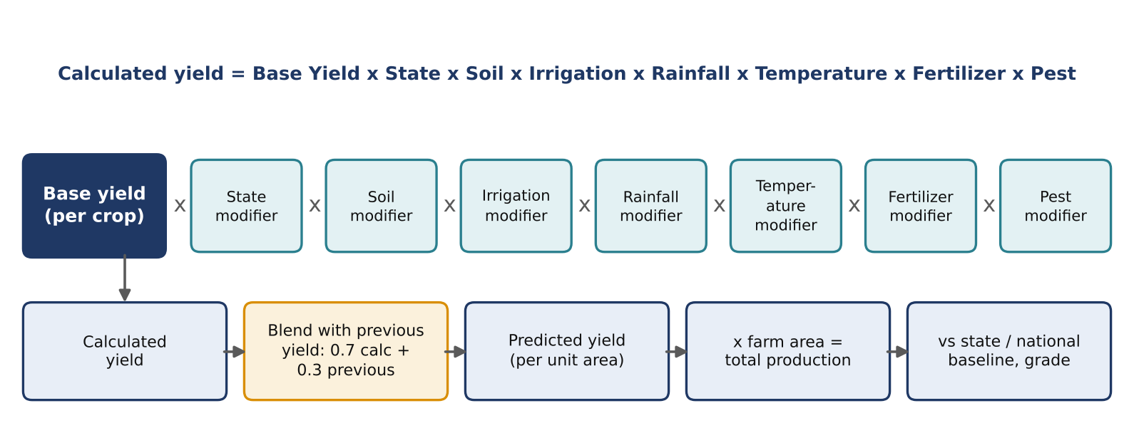
Figure 8.2 – Rule-based yield prediction engine
If a previous yield is supplied, the final prediction takes a 70 % contribution from the calculated value and a 30 % contribution from the previous yield. Total production is computed from the predicted yield and the farm area, and the result is compared with a state baseline and a national baseline. A confidence indicator is computed as the average of six factor scores; it is an internal model indicator and not a statistically calibrated probability.

8.5 Loan Eligibility Logic
Loan eligibility is derived from score ranges and then adjusted for debt burden and default history (Figure 8.3). A score of 80 or above maps to the highest eligibility tier; lower ranges progressively reduce the recommended maximum loan amount or require review. Debt burden can reduce the maximum amount to 75 %, 60 % or 40 % of the corresponding standard amount. A previous default can change an approval into a conditional approval, a review or a rejection, depending on the overall score.
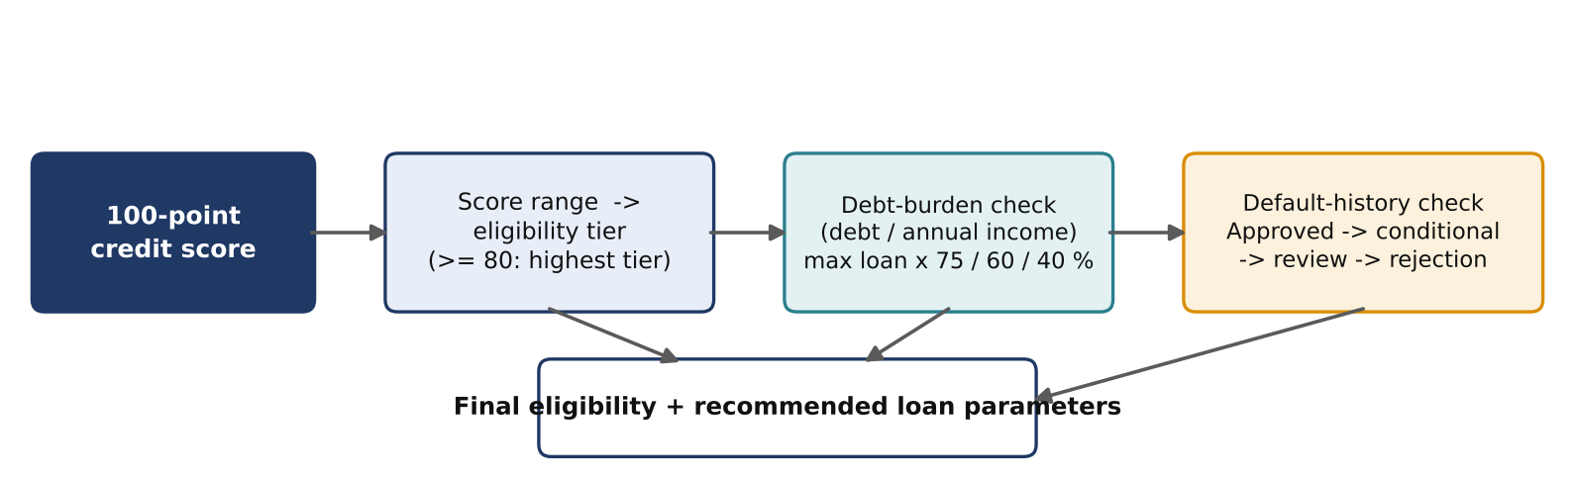
Figure 8.3 – Loan-eligibility decision logic
Table 8.3 – Loan-eligibility adjustments
Step | Rule
Score tier | ≥ 80: highest eligibility tier; lower ranges reduce the recommended maximum or require review
Debt burden | Maximum loan reduced to 75 %, 60 % or 40 % of the standard amount as the debt ratio rises
Default history | Approval may become conditional approval, review or rejection depending on the score
Loan parameters | Recommended amount, interest and tenure indicators (prototype policy values)

[Add the exact score-range boundaries, standard loan amounts, and the mapping of the 75 / 60 / 40 % reductions to the debt thresholds from the source code.]
These rules are application-specific heuristics. They must not be interpreted as regulatory lending criteria or as a replacement for a bank’s validated credit-risk model.

8.6 Why Rule-Based Logic
- No large labelled dataset of regional farm loans and yields is available for training.
- Each output can be traced to explicit rules, which supports explanation and audit.
- Computation is lightweight and runs entirely in the browser.
- The rules provide a clear baseline against which future trained models can be compared.

8.7 Evaluation Approach
Because no model is trained, standard metrics such as accuracy, precision, recall, F1-score, MAE, RMSE, R² and ROC-AUC are not reported. Evaluation in this report is functional: whether each module produces the stated outputs from the stated inputs (Chapters 10 and 11). The metrics above are listed in Chapter 13 as the protocol for a future trained version.

CHAPTER 9 – IMPLEMENTATION AND USER INTERFACE

9.1 Implementation Overview
The prototype is implemented with React and TypeScript using modular page and service components. It contains reusable user-interface components for forms, cards, charts, dialogs, progress indicators, tables and navigation. The main assessment pages are Farmer Registration, Banking History, Crop Planning, Soil Analysis, Credit Score and Dashboard.
Table 9.1 – Application pages and elements
Page | Main elements | Output
Farmer Registration | Account creation, personal and farm details | Farmer profile
Banking History | Account age, previous loans, repayment rate, income, debt, default history | Repayment and debt indicators
Crop Planning | Crop, season, area, irrigation, fertilizer, pesticide, previous yield | Crop plan and practice indicators
Soil Analysis | Regional soil attributes, environmental values | Soil-health and viability scores
Credit Score | Five-component breakdown, loan eligibility, adjustments | 100-point score and loan recommendation
Dashboard | Score components, loan history, crop information, expected yield, soil health | Charts and recommendations

9.2 Soil Data Service
The soil-data service contains regional entries for multiple Indian states and stores soil type, soil texture, pH, organic carbon, nitrogen, phosphorus, potassium, sulphur, zinc, iron, drainage quality, erosion level and suitable crops. The soil-analysis interface can also display environmental values obtained through the implemented external service integration.

9.3 Dashboard
The dashboard visualises the credit-score components, loan history, crop information, expected yield, soil-health score and recommendations. The yield view shows predicted yield, total production, state average, national average, a grade, factor scores, a monthly growth visualisation and recommendations. This visualisation layer is important because the system supports explainable screening rather than returning a single unexplained credit decision.

9.4 User Interface Screens
[Insert the application screenshots below, replacing each placeholder. Use a complete user journey for one example farmer.]
SCREENSHOT TO BE INSERTED
Registration page – farmer account and profile form
Figure 9.1 – Farmer registration page
SCREENSHOT TO BE INSERTED
Banking history and loan-record entry page
Figure 9.2 – Banking history page
SCREENSHOT TO BE INSERTED
Crop-planning page – crop, season, area, practices
Figure 9.3 – Crop planning page
SCREENSHOT TO BE INSERTED
Soil-analysis page – regional soil values and environmental data
Figure 9.4 – Soil analysis page
SCREENSHOT TO BE INSERTED
Credit-score page – five-component breakdown and loan eligibility
Figure 9.5 – Credit score and loan-eligibility page
SCREENSHOT TO BE INSERTED
Yield-prediction view – yield, production, baselines, grade, factor scores
Figure 9.6 – Crop-yield prediction view
SCREENSHOT TO BE INSERTED
Dashboard – score components, loan history, crop information, recommendations
Figure 9.7 – Dashboard overview

CHAPTER 10 – RESULTS AND ANALYSIS

10.1 Principal Analytical Outputs
The prototype produces three principal analytical outputs: an agricultural viability assessment, a 100-point credit assessment and a crop-yield planning estimate. The credit score is decomposed into five visible categories so that the user can see the source of the result, and the loan-eligibility module exposes its debt-related adjustments and recommendation messages.
Table 10.1 – Implemented analytical outputs
Module | Inputs | Output
Credit assessment | Banking, loans, income, farming, land, agriculture, crops | 0–100 score, eligibility, loan amount, interest / tenure indicators
Soil analysis | pH, organic carbon, nutrients, drainage, erosion, crop / season | Soil-health and agricultural-viability scores
Yield prediction | Crop, state, soil, irrigation, rainfall, temperature, fertilizer, pesticide, previous yield | Predicted yield, production, benchmark comparison, grade, recommendations
Dashboard | Stored assessment results | Charts, loan history, crop data, score breakdown, recommendations

10.2 Credit Assessment Output
The credit page reports the total score and the five component scores against their maxima (Table 8.1), followed by the loan-eligibility decision and any debt-burden or default adjustments. A user can therefore tell whether a low score arises from banking history, farming practice, land, agricultural viability or crop-market viability.

10.3 Yield Prediction Output
The yield module provides predicted yield, total production, state average, national average, a grade, factor scores, a monthly growth visualisation and recommendations. This is consistent with the literature’s emphasis on combining climate, soil and historical-yield information for agricultural prediction [4], [6].

10.4 Worked Example
[Insert one worked example from the running application: the input values, the five credit-score components, the total, the eligibility outcome, the predicted yield and production, and the benchmark comparison. Cite the screenshots in Figures 9.5–9.7. The source documents do not contain sample values, so none are given here.]

10.5 Interpretability Compared with Machine-Learning Approaches
Table 10.2 – Rule-based prototype compared with typical machine-learning approaches
Aspect | This prototype | Typical ML approach in the literature
Training data | None required | Large labelled dataset required
Explainability | Each output traceable to explicit rules | Often harder to explain; needs SHAP-like methods
Accuracy evidence | Not statistically measured | Measured with MAE, RMSE, R², ROC-AUC, F1
Default-probability estimate | Not provided | Provided by trained credit-risk models [3]
Adaptation to new data | Rules must be edited by hand | Retraining on new data
Deployment effort | Lightweight, client-side | Requires model hosting and monitoring

10.6 What the Results Do and Do Not Show
The principal strength of the prototype is interpretability: each major result can be traced to identifiable input categories and explicit rules. The prototype should not be reported as achieving a machine-learning accuracy because it does not train and validate a statistical model on a labelled dataset. Its deterministic nature also limits its ability to estimate real-world default probability or to generalise statistically.

CHAPTER 11 – TESTING AND VALIDATION

11.1 Testing Approach
Validation of this prototype is functional. Each module is exercised through the application using representative inputs, and the outputs are checked against the documented rules (point maxima, thresholds and formulas). Evidence is the screenshots in Chapter 9.

11.2 Test Cases
Table 11.1 – Test cases and evidence
Test ID | Description | Expected result | Evidence | Status
TC-01 | Register a farmer account | Profile saved and next step opens | Figure 9.1 | [run / attach]
TC-02 | Enter banking and loan history | Debt-to-income ratio derived; history stored | Figure 9.2 | [run / attach]
TC-03 | Enter crop plan and practices | Crop plan accepted and carried forward | Figure 9.3 | [run / attach]
TC-04 | Run soil analysis | Soil-health and viability scores shown | Figure 9.4 | [run / attach]
TC-05 | Compute credit score | Five components sum to the total (max 100) | Figure 9.5 | [run / attach]
TC-06 | High debt-to-income input | Debt penalty and reduced maximum loan applied | Figure 9.5 | [run / attach]
TC-07 | Previous default input | Approval changes to conditional / review / reject | Figure 9.5 | [run / attach]
TC-08 | Run yield prediction | Yield, production, baselines and grade shown | Figure 9.6 | [run / attach]
TC-09 | Supply previous yield | Prediction blends 70 % calculated + 30 % previous | Figure 9.6 | [run / attach]
TC-10 | Open dashboard | Saved results, charts and recommendations shown | Figure 9.7 | [run / attach]

Status entries are marked for the team to complete after running each case; no test result has been assumed.

11.3 Planned Tests
Table 11.2 – Planned tests
Test area | Description | Status
Unit tests | Scoring functions, thresholds, modifier calculations and the 70/30 blend | Planned
Input validation | Out-of-range, negative and missing values in all forms | Planned
Boundary tests | Scores at tier edges; debt ratios at exactly 40 %, 60 % and 80 % | Planned
Cross-browser and device checks | Rendering on several browsers and screen sizes | Planned
Persistence tests | Saving and retrieving assessments for several users | Planned
External validation | Comparison with real yields and loan outcomes | Planned
Security and privacy | Authentication, access control and handling of financial data | Planned

11.4 Validation Status
The system has been validated only as a functional prototype. Validation against real yield records, historical loan outcomes, field-level soil data or a bank’s credit policy has not been established and should not be assumed.

CHAPTER 12 – CHALLENGES AND LIMITATIONS

12.1 Challenges Encountered
- Combining two domains: agronomic and financial indicators have different scales and meanings and had to be reduced to a common 100-point framework.
- No labelled data: without historical loan-default and yield records, weights and thresholds had to be set by design rather than learned.
- Soil and regional data: authoritative field-level soil data were not available, so a static regional database was used.
- Balancing simplicity and realism: the interface needed to stay simple for users with limited digital literacy while exposing enough detail to explain each score.
- Many dependent inputs: a long staged workflow had to carry data consistently between pages and services.

12.2 Limitations
- The credit score is a hand-designed rule-based heuristic and has not been trained or calibrated against historical loan-default outcomes.
- The yield module uses predefined baselines and multipliers rather than a supervised model trained on a validated dataset.
- Regional soil information is a mock / static database for multiple Indian regions and should be replaced or validated with authoritative field-level data before production use.
- The confidence indicator is an internal heuristic and is not a statistical confidence interval or probability.
- Loan amounts, interest rates and tenure values are prototype policy rules and must not be treated as actual bank lending terms.
- Real-world deployment would require stronger data governance, privacy protection, fairness testing, model validation, auditability and integration with verified financial and agricultural data sources.

12.3 Ethical and Safety Considerations
Credit-related tools can affect people’s access to finance. The system is presented as a decision-support prototype and exposes the factors behind each result instead of a single opaque decision. Any real deployment would need informed consent, protection of financial and personal data, testing for unfair outcomes across farmer groups, clear communication of uncertainty, and review by agricultural and banking experts.

CHAPTER 13 – CONCLUSION AND FUTURE SCOPE

13.1 Conclusion
This project presented a data-driven Farm Credit Assessment and Agricultural Decision Support System that integrates financial, farming, land, soil, crop and environmental information into one web workflow. The system combines a transparent 100-point credit-scoring framework, agricultural viability analysis, debt-burden adjustments and a rule-based crop-yield prediction engine. The dashboard provides interpretable outputs and recommendations instead of relying on a single opaque decision.
The prototype demonstrates the feasibility of combining agricultural analytics and credit screening in one platform. Its current limitation is that the analytical rules are not statistically learned from a historical lending dataset; the system should therefore be regarded as a decision-support prototype. A validated historical dataset, machine-learning models, rigorous evaluation and real-world financial validation would be required before use in operational credit decisions.

13.2 Implementation Status
Table 13.1 – Implementation status
Component | Status
Farmer registration and profile management | Implemented
Banking history and loan record management | Implemented
Crop planning and farming-practice collection | Implemented
Soil analysis and agricultural viability scoring | Implemented (static regional data)
100-point credit score and loan eligibility | Implemented (heuristic rules)
Crop-yield prediction and benchmark comparison | Implemented (rule-based)
Dashboard and saved assessment data | Implemented
Trained machine-learning models | Not implemented – future work
Real-time weather integration | Partial / future – confirm extent
Independent validation and deployment | Not completed

13.3 Project Plan
Table 13.2 – Project phases
Phase | Description
Phase 1 | Requirement analysis and finalisation of agricultural parameters
Phase 2 | Data collection and preprocessing of crop, soil and climate-related data
Phase 3 | Development of rule-based yield and credit assessment logic
Phase 4 | Dashboard design: predicted yield, confidence score and comparisons
Phase 5 | Integration, testing and validation of the complete system
Phase 6 | Documentation and final presentation

13.4 Future Scope
- Collect historical loan outcomes and farm-production records to train supervised models for probability of default, repayment and yield prediction.
- Evaluate candidate models – logistic regression, Random Forest, gradient boosting and calibrated ensembles – with a proper train–validation–test protocol and metrics such as ROC-AUC, precision, recall, F1-score, MAE, RMSE and R² [4].
- Add satellite and remote-sensing features, time-series weather data, field-level soil measurements, market-price data and crop-insurance information.
- Add explainable-AI methods such as SHAP and uncertainty estimation.
- Provide multilingual interfaces for wider farmer access.
- Integrate with verified agricultural and banking services and strengthen data governance, privacy and fairness testing.

CHAPTER 14 – REFERENCES AND APPENDICES

14.1 References
[1] K. Jhajharia, P. Mathur, S. Jain, and S. Nijhawan, “Crop Yield Prediction using Machine Learning and Deep Learning Techniques,” Procedia Computer Science, vol. 218, pp. 406–417, 2023, doi: 10.1016/j.procs.2023.01.023.
[2] E. Elbasi, C. Zaki, A. E. Topcu, W. Abdelbaki, A. I. Zreikat, E. Cina, A. Y. Shdefat, and L. Saker, “Crop Prediction Model Using Machine Learning Algorithms,” Applied Sciences, vol. 13, no. 16, art. 9288, 2023, doi: 10.3390/app13169288.
[3] N. Chai, M. Z. Abedin, X. Wang, and B. Shi, “Growth potential of machine learning in credit risk predicting of farmers in the industry 4.0 era,” International Journal of Finance & Economics, vol. 30, no. 3, pp. 2163–2185, 2025, doi: 10.1002/ijfe.3010.
[4] “Crop Yield and Soil Moisture Prediction Using Machine Learning Algorithms,” in Machine Learning Applications: From Computer Vision to Robotics, Wiley-IEEE Press, 2024, pp. 183–194, doi: 10.1002/9781394173358.ch11.
[5] N. Pushpalatha, Nandhini, G. M. Santhiya, F. Khan, and A. Alkhayyat, “A Farmer Friendly AI Powered Smart Agriculture Loan Appraisal System by Considering Their Land Yield Capacity,” in Proc. 2nd Symposium on Smart, Sustainable, and Secure Internet of Things (S4IoT 2025), Lecture Notes in Electrical Engineering, vol. 1513, Springer, 2026, pp. 217–228, doi: 10.1007/978-981-95-5136-1_21.
[6] R. Kumar, P. K. Singh, and R. K. Tiwari, “Prediction of agricultural production based on multivariate data with feature aware machine learning models,” Discover Artificial Intelligence, vol. 6, art. 796, 2026, doi: 10.1007/s44163-026-01987-6.
[7] M. Snehalatha and A. Patil, “AgriYieldAI an AI driven decision support system for crop yield prediction using YieldFusionNet,” Discover Computing, vol. 29, art. 222, 2026, doi: 10.1007/s10791-026-10096-y.

Appendix A – Input Variable Descriptions
Variable | Description
Crop type | Crop planned for cultivation
Location (state / district) | Region used for soil data, state modifier and baseline
Season | Cropping season of the plan
Farm area | Cultivated area; used for total production and land score
Rainfall | Rainfall value used by the rainfall modifier
Temperature | Temperature value used by the temperature modifier
Soil type | Soil class used for suitability and soil modifier
Irrigation | Irrigation availability / method
Fertilizer usage | Fertilizer practice used by the fertilizer modifier
Pesticide usage | Pest-management practice used by the pest modifier
Previous crop yield | Optional; blended at 30 % into the prediction
Farming experience | Years of farming; farming-score input
Land ownership | Ownership status; land-score input
Banking history | Account age, previous loans, average repayment rate
Loan history | Past loans and defaults
Income | Monthly income; annualised for the debt ratio
Outstanding debt | Current debt; numerator of the debt-to-income ratio

Appendix B – Abbreviations
Abbreviation | Meaning
AI | Artificial intelligence
DTI | Debt-to-income ratio
EDA | Exploratory data analysis
IoT | Internet of things
LSTM | Long short-term memory
MAE / RMSE | Mean absolute error / root mean squared error
ML | Machine learning
N, P, K | Nitrogen, phosphorus, potassium
ROC-AUC | Area under the receiver-operating-characteristic curve
SHAP | Shapley additive explanations
SVM | Support vector machine

Appendix C – Scoring Parameters Summary
Parameter | Value
Credit score maximum | 100 (30 + 20 + 15 + 20 + 15)
Agricultural viability maximum | 100 (40 + 35 + 25), scaled to 20 in credit score
Debt-to-income penalty thresholds | 40 %, 60 %, 80 %
Maximum loan reductions for debt burden | 75 %, 60 %, 40 % of the standard amount
Highest eligibility tier | Score ≥ 80
Previous-yield blend | 70 % calculated + 30 % previous yield
Confidence indicator | Average of six factor scores (heuristic)

Appendix D – Items to Confirm and Source Code Repository
GitHub repository: [insert repository link]
The following details were not present in the supplied project documents and should be confirmed from the source code before submission:
- [Exact UI component and chart libraries, build tool and versions]
- [Number of crops supported and the base-yield values used]
- [Number of states in the soil database and the state / national baseline values]
- [Identity of the six factor scores used in the confidence indicator]
- [Score-range boundaries for eligibility tiers; standard loan amounts, interest and tenure values]
- [External weather / soil service used and the extent of its integration]
- [Supabase tables and authentication rules]
- [Course Coordinator and HOD names for the certificate and acknowledgement]

